

## DOMAIN: CLOUD APPLICATION DEVELOPMENT

**PROJECT NAME: Media Streaming with IBM Cloud Video Streaming**

**PHASE 4**

**DEVELOPMENT PART 2**

IBM offers a video streaming platform that allows organizations to stream live and on-demand video content. This service includes adaptive bit-rate streaming for optimal video quality, content protection, and analytics for audience insights.

**Development Part 2:**

In second, we have designed a main page that shows main features which Movies, Series and Lives. And added a style to our main page to make a more attractive scenario for the users. Highlighting of featured. It will provide a great experience in which you can access the media according to your mood and currently how you feel.

**Source Code** **of Login:**

**Html code with styles:**

<!DOCTYPE html>

<html>

<head>

<style>

body {

font-family: Arial, sans-serif;

background-color: #00ff88d4;

display: flex;

justify-content: center;

align-items: center;

height: 100vh;

margin: 0;

}

.login-container {

background-color: #1cbfca;

padding: 40px;

border-radius: 5px;

box-shadow: 0 0 10px rgba(27, 51, 213, 0.36);

}

.input-field {

margin-bottom: 20px;

}

.input-field label {

display: block;

margin-bottom: 5px;

}

.input-field input {

width: 100%;

padding: 8px;

border-radius: 5px;

border: 1px solid #2fe0da;

}

.login-btn {

width: 100%;

padding: 10px;

border-radius: 5px;

border: none;

background-color: #0a12e4;

color: white;

font-size: 16px;

cursor: pointer;

}

</style>

</head>

<body>

<div class="login-container">

<h2><center>Login</center></h2>

<div class="input-field">

<label for="username">Username or email</label>

<input type="text/email" id="username" name="username" placeholder="Enter your username or email I'd">

</div>

<div class="input-field">

<label for="password">Password</label>

<input type="password" id="password" name="password" placeholder="Enter your password">

</div>

<button class="login-btn">Login</button>

</div>

</body>

</html>

**Login page resulted as:**

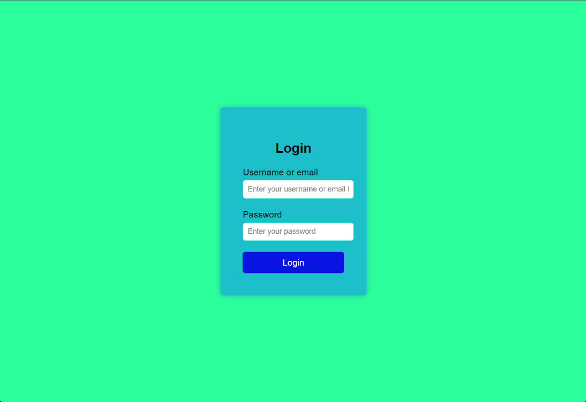

**Static webpage for Media Streaming:**

**Source code:**

<!DOCTYPE html>

<html>

<head>

<style>

body {

font-family: Arial, sans-serif;

background-color: #f4f4f4;

margin: 0;

padding: 0;

}

.button {

border: none;

color: white;

padding: 10px;

text-align: center;

text-decoration: none;

display: inline-block;

font-size: 14px;

margin: 4px 2px;

cursor: pointer;

}

.button:hover {

background-color: #2500e1d8

}

.button:active {

background-color: #131513;

box-shadow: 0 5px #666;

transform: translateY(4px);

}

.button5 {

background-color: #0062ff;

border-radius: 12px;

}

.but1 {

background-color: #d51086;

border-radius: 12px;

}

.but2 {

background-color: #d51010;

border-radius: 12px;

}

.button4 {

background-color: #0062ff;

border-radius: 12px;

}

.button3 {

background-color: #0062ff;

border-radius: 12px;

}

.navbar {

display: flex;

justify-content: space-between;

align-items: center;

background-color: #0e0e0bd8;

color: #fff;

padding: 15px;

}

.main-content {

display: flex;

flex-direction: column;

align-items: center;

padding: 20px;

}

.video-player {

width: 70%;

margin-bottom: 20px;

}

.interaction-section {

width: 70%;

display: flex;

justify-content: space-between;

}

</style>

</head>

<body>

<div class="navbar">

<div>

<img src="img_sample.png" width="150" height="50">

<input type="text" placeholder="Search" style="padding: 8px;">

</div>

<div>

<button class="button button3">Profile</button>

<button class="button button4">Home</button>

<button class="button button5">lagout

</button>

</div>

</div>

<div class="main-content">

<div class="video-player">

<iframe width="100%" height="400px" src="https://www.youtube.com/embed/t06RUxPbp_c?si=6_O6iBT1xSlnX02M" title="YouTube video player" frameborder="0" allow="accelerometer; autoplay; clipboard-write; encrypted-media; gyroscope; picture-in-picture; web-share" allowfullscreen></iframe>

</div>

<div class="interaction-section">

<button class="button but1">Like</button>

<input type="text" placeholder="Write a comment" style="padding: 8px; flex-grow: 2; margin: 0 10px;">

<button class="button but2">Share</button>

</div>

</div>

</body>

</html>

**Sample static webpage resulted as:**

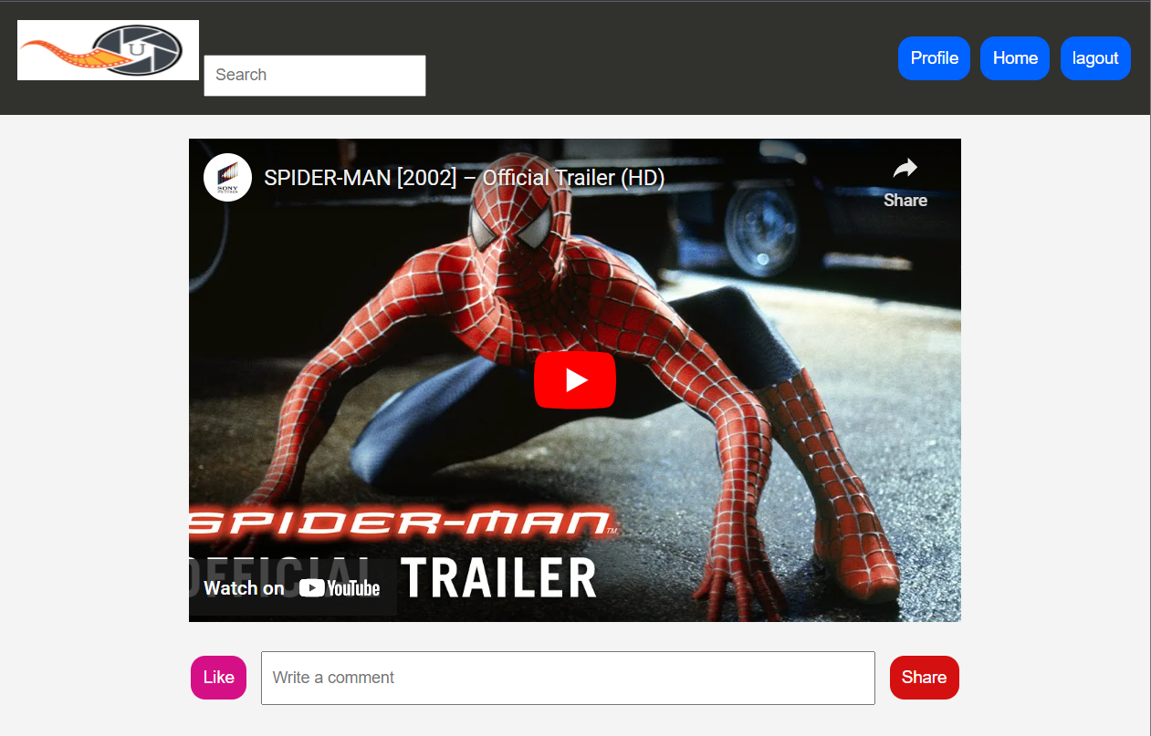

|  |  |  |
| --- | --- | --- |
| S.No. | Team Members | Email ID |
| 1 | Mohamed Shameer S | [shameermohamad12@gmail.com](mailto:shameermohamad12@gmail.com) |
| 2 | Lakshmi Narayanan R | [narayananaja1017@gmail.com](mailto:narayananaja1017@gmail.com) |
| 3 | Kaviarasu K | [kaviarasu232004@gmail.com](mailto:kaviarasu232004@gmail.com) |
| 4 | Akash G | [akashganesan8@gmail.com](mailto:akashganesan8@gmail.com) |